DC Motor with Arduino

**Aim**:

Design and implement a circuit to move a dc motor both clockwise and anticlockwise.

**Code**:

// This code is to move dc motor clockwise and anticlockwise

// Press the button and the motor will start rotating

int enablePin = 11;

int in1Pin = 10;

int in2Pin = 9;

int switchPin = 7;

int potPin = 0;

void setup ()

{

pinMode(in1Pin, OUTPUT);

pinMode(in2Pin, OUTPUT);

pinMode(enablePin, OUTPUT);

pinMode(switchPin, INPUT_PULLUP);

}

void loop ()

{

int speed = analogRead(potPin) / 4;

boolean reverse = digitalRead(switchPin);

setMotor(speed, reverse);

}

Void setMotor(int speed, Boolean reverse)

{

analogWrite(enablePin, speed);

digitalWrite(in1Pin, ! reverse);

digitalWrite(in2Pin, reverse);

}

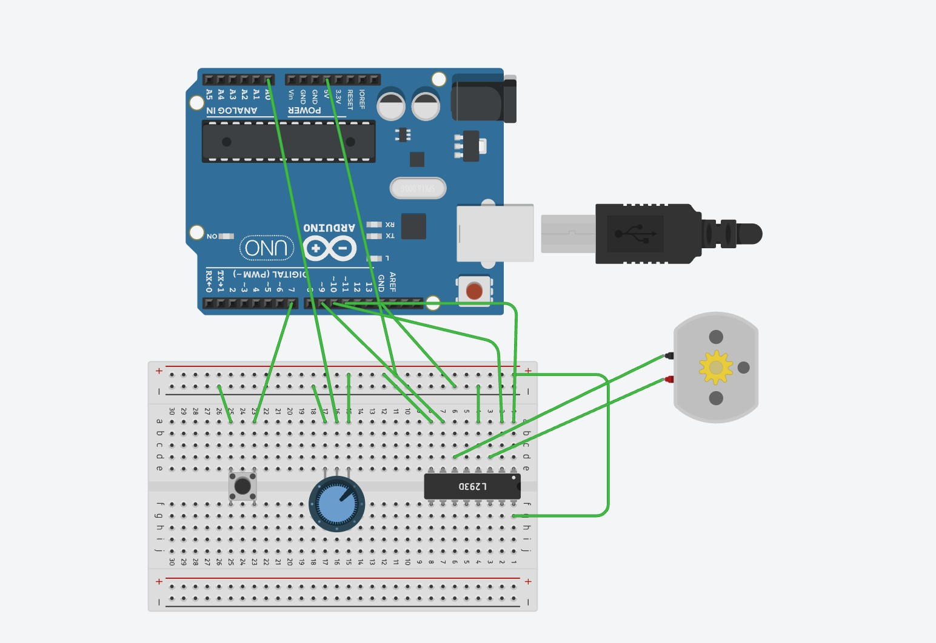**Connection diagram on Tinkercad:**